MIT WORLD PEACE UNIVERSITY
SCHOOL OF COMPUTER ENGINEERING AND TECHNOLOGY
PYTHON PROGRAMMING LABORATORY
Course Code: CSE10040
ASSIGNMENT NO.: 7

Experiment Title: Data Visualization using Line, Bar, Scatter Plots and Heatmap.

Problem Statement
Load the dataset and plot the data using line, bar, scatter plots, and heatmap with Seaborn and Matplotlib libraries.

Aim

Write a Python program to load a small CSV dataset and visualize the data using line, bar, scatter, and heatmap plots.

Objectives
After completing this experiment, students will be able to:
- To understand the importance of data visualization.
- To create a line plot, bar plot and scatter plot using Matplotlib.
- To create a heatmap using Seaborn.

Course Outcome Mapping
CO: 4
Relevant Course Outcome: Apply Python programming concepts and libraries to load, process, analyze, and visualize data.

Theory
Data Visualization
Data visualization is the graphical representation of data. It helps in understanding patterns, trends, comparisons, relationships, and other important information present in a dataset.

Pandas
Pandas is a Python library used for data manipulation and analysis. It provides the DataFrame data structure for storing and processing tabular data.

df = pd.read_csv("filename.csv")

Line Plot
A line plot represents data points connected by lines. It is useful for showing variation or trends in data.

plt.plot(x, y)

Bar Plot
A bar plot represents categorical data using rectangular bars. It is useful for comparing values between different categories.

plt.bar(x, y)

Scatter Plot
A scatter plot displays individual data points on two axes. It is useful for studying the relationship between two numerical variables.

plt.scatter(x, y)

Heatmap
A heatmap represents numerical values using different shades of colour. It is useful for visualizing a correlation matrix.

sns.heatmap(data, annot=True)

Correlation
Correlation indicates the relationship between two numerical variables. The correlation coefficient generally ranges from -1 to +1. A value close to +1 indicates a strong positive relationship, a value close to -1 indicates a strong negative relationship, and a value close to 0 indicates a weak or no linear relationship.

df[["Maths", "Python", "Attendance"]].corr()

Matplotlib and Seaborn
Matplotlib is a Python library used for creating different types of graphs and plots. Seaborn is a Python visualization library built on Matplotlib and provides a convenient interface for creating statistical visualizations such as heatmaps.

Platform
Operating System: Windows / Ubuntu
Python Environment: Python 3.x
Recommended: Jupyter Notebook, IDLE, Visual Studio Code, PyCharm, or Google Colab.

Algorithm / Pseudocode
- Start.
- Import Pandas, Matplotlib, and Seaborn.
- Load the CSV file using pd.read_csv().
- Display the dataset.
- Create a line plot of Python marks.
- Create a bar plot of Maths marks.
- Create a scatter plot of Maths versus Python marks.
- Calculate the correlation matrix for Maths, Python, and Attendance.
- Create a heatmap of the correlation matrix using Seaborn.
- Display all plots with suitable titles and axis labels.
- Stop.

Input
The program requires a CSV file named sample_data_assignment_07.csv containing the columns Student, Maths, Python, Attendance, and City.

Student,Maths,Python,Attendance,City
Amit,75,80,85,Pune
Bhavna,82,78,90,Mumbai
Chetan,68,70,78,Pune
Diya,90,92,95,Nashik
Esha,72,75,80,Mumbai
Farhan,85,88,92,Pune

Program / Implementation

import pandas as pd
import matplotlib.pyplot as plt
import seaborn as sns
# Load the CSV dataset
df = pd.read_csv("sample_data_assignment_07.csv")
# Display the dataset
print("Dataset:")
print(df)
# Line Plot
plt.figure(figsize=(7, 4.5))
plt.plot(df["Student"], df["Python"], marker="o")
plt.title("Python Marks of Students")
plt.xlabel("Student")
plt.ylabel("Python Marks")
plt.grid(True)
plt.show()
# Bar Plot
plt.figure(figsize=(7, 4.5))
plt.bar(df["Student"], df["Maths"])
plt.title("Maths Marks of Students")
plt.xlabel("Student")
plt.ylabel("Maths Marks")
plt.show()
# Scatter Plot
plt.figure(figsize=(7, 4.5))
plt.scatter(df["Maths"], df["Python"], s=70)
plt.title("Maths vs Python Marks")
plt.xlabel("Maths Marks")
plt.ylabel("Python Marks")
plt.grid(True)
plt.show()
# Correlation Matrix and Heatmap
correlation = df[["Maths", "Python", "Attendance"]].corr()
print("Correlation Matrix:")
print(correlation)
plt.figure(figsize=(6.5, 5))
sns.heatmap(correlation, annot=True, cmap="Blues", vmin=-1, vmax=1)
plt.title("Correlation Heatmap")
plt.show()

Output
Line Plot:
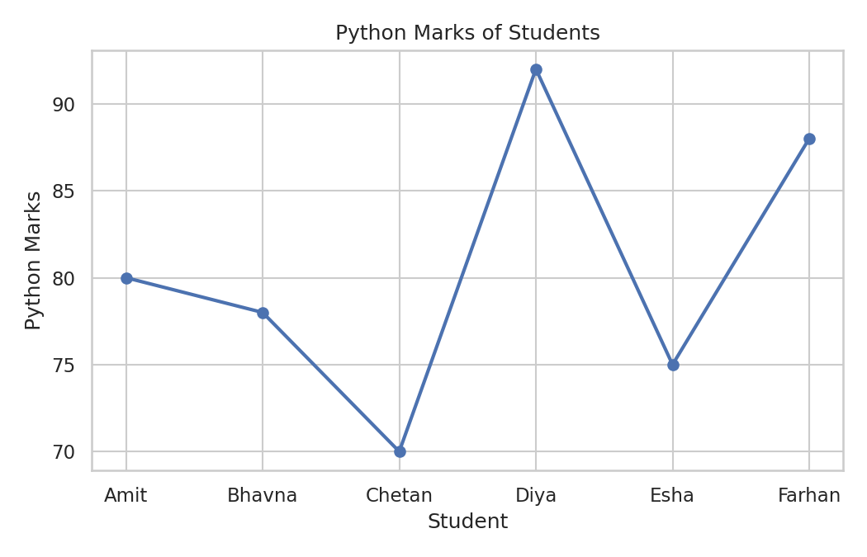
Bar Plot:
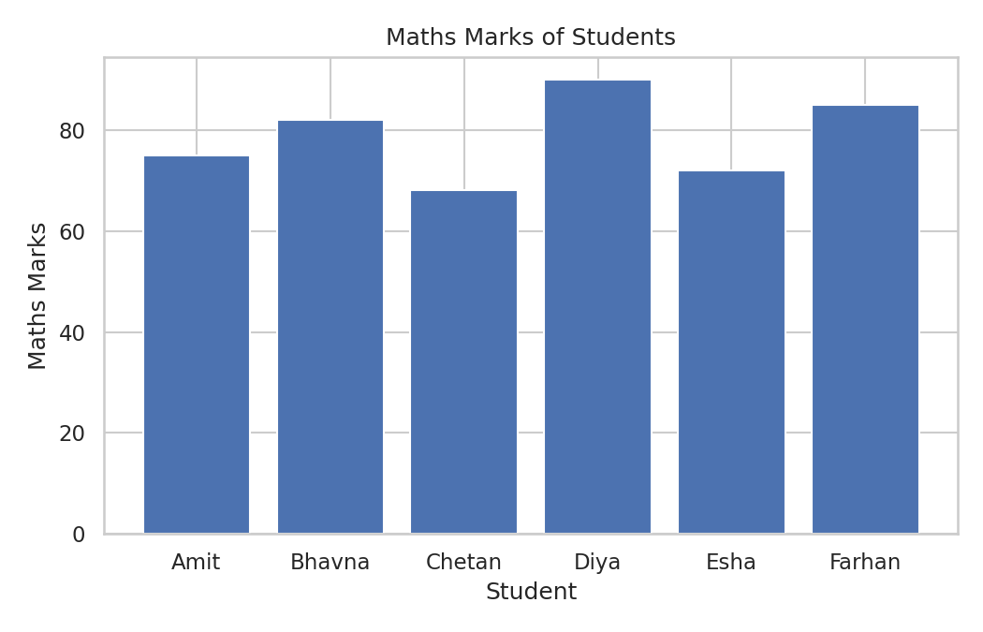
Scatter Plot:
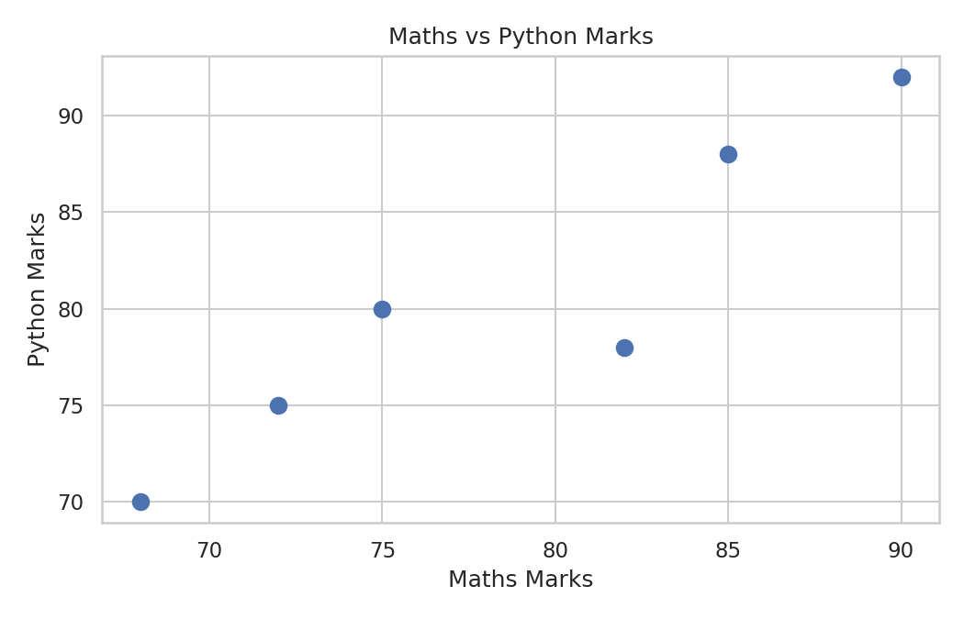
Heatmap:
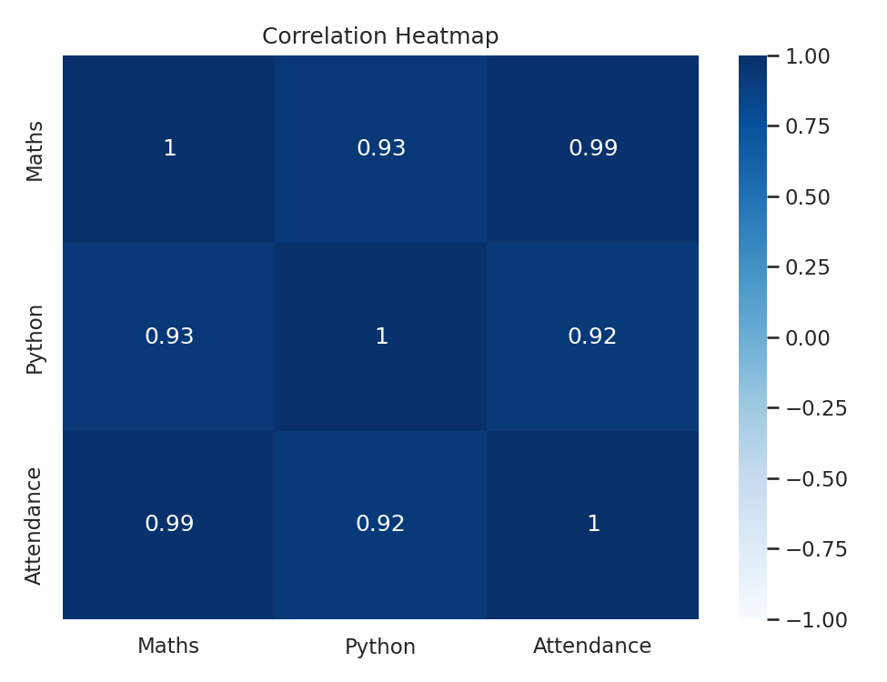

Test Cases
Students should test the program using multiple valid and invalid inputs wherever applicable.

Result / Conclusion
The given Python program was successfully implemented and executed.
The dataset was successfully loaded using Pandas and visualized using Matplotlib and Seaborn. Line, bar, scatter, and heatmap plots were created to understand trends, comparisons, relationships, and correlations in the dataset.

Learning Outcome:

Students understood and implemented Loading and exploring a CSV dataset using Pandas, Creating line plots using Matplotlib, Creating bar plots using Matplotlib, Creating scatter plots using Matplotlib,Calculating correlation among numerical attributes, Creating heatmaps using Seaborn,
Interpreting data using different visualization techniques.

FAQs / Viva Questions
- Explain the use of plt.plot().
- What is the purpose of plt.bar()?
- What information can be obtained from plt.scatter()?
- What does the correlation matrix represent?
- Explain the use of sns.heatmap().
- Why are numerical columns used for correlation?

Challenge / Extension Task
Modify the program to perform the following additional task:
- Create a histogram of Python marks.
- Create a box plot for Maths and Python marks.
- Create a pie chart showing the number of students from each city.
- Add appropriate titles, axis labels, and legends to the plots.
- Calculate and display the average Maths marks, average Python marks, and average Attendance.
- Allow the user to provide the CSV file name as input.

Faculty Evaluation
Parameter | Marks | Faculty Remarks
Understanding of Problem
Algorithm / Logic
Program Implementation
Execution & Test Cases
Journal / Documentation
Viva
Total

Faculty Signature: ______________________ Date: ______________________

